CHRONIC KIDNEY DISEASE PREDICTION USING MACHINE LEARNING

Machine Learning Laboratory Project Report

Submitted By:

Name: ShubshreeUmbarkar

Branch: Information Technology

Semester: 5th Semester

Roll Number: 24I5169

Submitted To:

Faculty Name:

Institute:

Institute of Engineering and Technology (IET), DAVV, Indore

Academic Session: 2026–2027

INDEX
S. No. Contents

1 Abstract

2 Introduction

3 Aim and Objectives

4 Requirements

4.1 Software Requirements

4.2 Hardware Requirements

5 Theory

5.1 Chronic Kidney Disease

5.2 Machine Learning Classification

5.3 Random Forest Classifier

5.4 Missing-Value Handling

5.5 Categorical Encoding

5.6 Train-Test Split

5.7 Evaluation Metrics

6 Methodology

6.1 Dataset Collection

6.2 Data Preprocessing

6.3 Feature Processing

6.4 Model Training

6.5 Model Testing

6.6 Visualization and Saving

6.7 System Architecture

7 Implementation: Code and Output
7.1 Importing Libraries and Loading Dataset

7.2 Data Cleaning and Preparation

7.3 Preprocessing Pipeline and Model Training

7.4 Model Evaluation

7.5 Sample Prediction

7.6 Confusion Matrix Visualization

7.7 Feature Importance

7.8 Saving the Trained Model

8 Results and Discussion

8.1 Classifier Performance

8.2 Sample Prediction

8.3 Feature Importance

8.4 Limitations

9 Conclusion

10 Future Scope

11 References

---

1. Abstract

Chronic Kidney Disease (CKD) is a medical condition in which the kidneys gradually lose their ability to filter waste and excess fluids from the blood. Early identification of CKD is important because timely medical evaluation and treatment may help manage the condition and reduce the risk of complications. Machine learning can assist in analyzing medical data and identifying patterns associated with diseases.

In this project, a machine learning model is developed to predict whether a patient belongs to the Chronic Kidney Disease or No Chronic Kidney Disease class. The project uses the publicly available UCI Chronic Kidney Disease dataset, which contains 400 patient records and 24 input features related to medical measurements and clinical observations.

The dataset is processed by handling missing values, separating numerical and categorical features, and converting categorical data into a machine-readable format. A Random Forest Classifier is trained using 80% of the records, while the remaining 20% are used for testing. The model is implemented in Python using Google Colab and libraries such as Pandas, NumPy, and Scikit-learn.

The model achieved 100% accuracy on the particular test split used in this project. A confusion matrix, classification report, sample prediction, and feature importance graph are used to examine the model's output. The trained model is also saved as a file for later use.

This project demonstrates the application of machine learning to a healthcare classification problem. It is intended for educational purposes only and must not be used as a substitute for professional medical diagnosis.

2. Introduction

Chronic Kidney Disease is a condition in which kidney function is damaged or decreases over time. Healthy kidneys remove waste products and excess fluid from the blood and help maintain the body's chemical balance. When the kidneys do not function properly, waste products and fluids may accumulate in the body.

Early detection of kidney disease is important because the condition may progress without obvious symptoms during its initial stages. Doctors evaluate kidney health using medical history, physical examinations, laboratory tests, and other clinical information. Analyzing multiple patient measurements manually can be time-consuming.

Machine learning is a branch of artificial intelligence that enables computers to learn patterns from data and make predictions. In healthcare-related research, machine learning algorithms can analyze patient records and identify relationships between input features and known medical classifications.

In this project, machine learning is applied to a Chronic Kidney Disease dataset. Patient attributes are provided to a trained classification model, which predicts one of two classes: CKD or No CKD. The model learns patterns from labelled training records and is evaluated using a separate test set.

The Random Forest algorithm is selected because it combines multiple decision trees to make a classification decision. It can work with a mixture of numerical and categorical features when the data is appropriately preprocessed.

The overall process followed in this project is:

- Obtain the CKD dataset from the UCI Machine Learning Repository.

- Inspect the dataset and identify missing values.

- Separate the input features from the target class.

- Handle missing numerical and categorical values.

- Encode categorical features into numerical representations.

- Divide the dataset into training and testing sets.

- Train a Random Forest classification model.

- Evaluate the model using accuracy, a classification report, and a confusion matrix.

- Test a sample patient record and visualize feature importance.

- Save the trained model for future use.

3. Aim and Objectives

3.1 Aim

To design and implement a machine learning-based system that predicts the Chronic Kidney Disease class of a patient using clinical data and evaluates the model's performance using appropriate classification metrics.

3.2 Objectives

- To study the application of machine learning in healthcare classification.

- To use a publicly available Chronic Kidney Disease dataset.

- To examine the dataset and identify missing or inconsistent values.

- To preprocess numerical and categorical input features.

- To divide the dataset into training and testing subsets.

- To train a Random Forest Classifier for CKD prediction.

- To predict whether a sample patient record belongs to the CKD or No CKD class.

- To evaluate the model using accuracy, precision, recall, F1-score, and a confusion matrix.

- To visualize the confusion matrix and the importance of input features.

- To save the trained model for future use.

- To understand the limitations of machine learning models in medical applications.

4. REQUIREMENTS

The Chronic Kidney Disease Prediction Using Machine Learning project requires suitable software and hardware to develop, train, test, and execute the machine learning model.

4.1 Software Requirements

1. Operating System: Windows, Linux, or macOS.
2. Platform: Google Colab.
3. Programming Language: Python.
4. Libraries: Pandas, NumPy, Scikit-learn, Matplotlib, Seaborn, and Joblib.
5. Dataset: UCI Chronic Kidney Disease dataset.
6. Internet Browser: Google Chrome or any compatible browser.

4.2 Hardware Requirements

1. Processor: Intel or AMD processor.
2. RAM: Minimum 4 GB.
3. Storage: Sufficient space to save the notebook, dataset, model, and output images.
4. Internet Connection: Required to access Google Colab and download the dataset.
5. Device: Laptop or desktop computer.
5. THEORY

5.1 Chronic Kidney Disease

Chronic Kidney Disease (CKD) is a medical condition in which the kidneys gradually lose their ability to filter waste products and excess fluid from the blood. Early detection is important because timely medical care can help manage the condition and slow its progression.

CKD can be associated with factors such as diabetes, high blood pressure, and other kidney-related disorders. Medical tests and patient health records provide useful information for identifying possible kidney problems.

In this project, a machine learning model is developed to classify patient records into two categories: CKD and No CKD. The project demonstrates how machine learning can assist in analyzing medical data. However, its predictions are for educational purposes only and cannot replace professional medical diagnosis.

5.2 Machine Learning Classification

Machine Learning (ML) is a branch of Artificial Intelligence that enables computers to learn patterns from data and make predictions without being explicitly programmed for every situation.

Classification is a type of supervised machine learning in which a model learns from labeled examples and predicts the category of new data.

In this project, the classification model uses patient information as input and predicts one of two classes:

1. CKD — Chronic Kidney Disease.
2. No CKD — No Chronic Kidney Disease.

The model learns patterns from the training dataset and evaluates its predictions using a separate testing dataset.

5.3 Random Forest Classifier

Random Forest is a supervised machine learning algorithm used for classification and regression tasks. It consists of multiple decision trees that work together to produce a final prediction.

Each decision tree learns patterns from the training data. For classification, the individual trees vote for a class, and the forest combines their predictions to determine the final result.

The main advantages of Random Forest are:

1. It can handle complex relationships in data.
2. It can work with many input features.
3. It can reduce overfitting compared with a single decision tree in many situations.
4. It can provide feature importance scores.
5. It is suitable for classification problems involving numerical and categorical information when the data is properly preprocessed.

In this project, the Random Forest Classifier is trained to predict whether a patient record belongs to the CKD or No CKD category.

5.4 Missing-Value Handling

Medical datasets may contain missing values because some tests or patient details are not available. Missing values must be handled before training a machine learning model.

This project uses two imputation methods:

1. Median Imputation: Missing numerical values are replaced with the median of the corresponding feature. The median is the middle value when the observations are arranged in order.

2. Most-Frequent Imputation: Missing categorical values are replaced with the most frequently occurring category in the corresponding feature.

These methods allow the model to use records containing incomplete information. The imputation values are learned from the training data through the preprocessing pipeline to avoid using test data during model fitting.

5.5 Categorical Encoding

Machine learning algorithms generally require numerical inputs. However, medical datasets may contain categorical values such as yes/no responses or other text-based categories.

Categorical encoding converts these categories into numerical representations that a machine learning model can process.

This project uses One-Hot Encoding for categorical features. It creates separate binary columns for different categories, using values such as 0 and 1 to represent whether a category is present.

The project uses "OneHotEncoder(handle_unknown="ignore")". This setting allows the model to handle previously unseen categories during prediction without producing an encoding error.

5.6 Train-Test Split

The train-test split is a method of dividing a dataset into two separate parts.

Training Set: The data used to train the machine learning model.

Testing Set: The data used to evaluate how the trained model performs on records that were not used for training.

In this project, the dataset is divided into 80% training data and 20% testing data. The split uses stratification to maintain the approximate class proportions in both sets.

The "random_state=42" parameter makes the split reproducible, while stratification helps ensure that both classes are represented in the training and testing sets.

5.7 Evaluation Metrics

Evaluation metrics are used to measure the performance of a classification model.

1. Accuracy: Accuracy measures the proportion of all predictions that are correct.

Accuracy = Correct Predictions / Total Predictions

2. Precision: Precision measures the proportion of records predicted as a particular class that actually belong to that class.

3. Recall: Recall measures the proportion of actual records belonging to a class that the model correctly identifies.

4. F1-Score: The F1-score combines precision and recall into a single measure using their harmonic mean.

5. Confusion Matrix: A confusion matrix compares actual classes with predicted classes. It shows correct predictions and misclassifications for each class.

These metrics are used to evaluate the CKD prediction model. In medical applications, accuracy alone is not sufficient; recall, precision, and independent validation are also important.

6. METHODOLOGY

The methodology describes the steps followed to develop the Chronic Kidney Disease Prediction Using Machine Learning project. It includes dataset collection, preprocessing, model training, testing, evaluation, visualization, and saving the trained model.

6.1 Dataset Collection

The Chronic Kidney Disease dataset was obtained from the UCI Machine Learning Repository using the "ucimlrepo" Python library. The dataset contains 400 patient records, 24 input features, and one target variable.

The input features contain numerical and categorical information related to patient health. The target variable indicates whether the record belongs to the CKD or No CKD category.

The dataset is used to train and evaluate the machine learning model.

6.2 Data Preprocessing

Data preprocessing is an important step because raw datasets may contain missing values and inconsistent data.

In this project, the dataset was inspected, and the input features were separated from the target variable. Missing values were handled using median imputation for numerical features and most-frequent imputation for categorical features.

The target labels were prepared for classification. After preprocessing, the dataset was divided into training and testing sets.

6.3 Feature Processing

The dataset contains both numerical and categorical features. These features require different preprocessing methods before they can be used by the model.

Numerical features are processed using median imputation, while categorical features are processed using most-frequent imputation and One-Hot Encoding.

A preprocessing pipeline is used to apply these operations consistently. It also helps ensure that the preprocessing steps are fitted on the training data rather than the test data.

6.4 Model Training

The Random Forest Classifier is used for training the CKD prediction model. It consists of multiple decision trees that combine their predictions to classify patient records.

The model is configured with 200 decision trees, "random_state=42", and "class_weight="balanced"".

The dataset is divided into 80% training data and 20% testing data. Stratified splitting is used to maintain the approximate proportion of both classes.

The model learns patterns from the training data and uses them to predict the target class.

6.5 Model Testing

After training, the model is evaluated using the testing dataset, which contains records not used during model fitting.

The model's predictions are compared with the actual labels. Accuracy, precision, recall, F1-score, and the confusion matrix are used to examine its performance.

The test split in this project produced 100% accuracy. However, this result applies only to the particular test split and does not establish that the model is clinically reliable.

6.6 Visualization and Saving

Visualizations are created to understand the model's performance and the relative importance of input features.

The confusion matrix presents the comparison between actual and predicted classes. The feature-importance graph displays the relative importance scores assigned by the Random Forest model.

The trained preprocessing and classification pipeline is saved in a ".pkl" file using Joblib. This allows the saved model to be loaded later for predictions without training it again, provided the required software environment and compatible input features are available.

6.7 System Architecture

The system architecture represents the sequence of operations performed by the CKD prediction system.

The process begins with dataset collection and proceeds through preprocessing, feature encoding, model training, and evaluation. Once trained, the model can receive a patient record and generate a predicted class.

System Architecture Diagram:

Dataset Collection
↓
Data Inspection and Cleaning
↓
Missing-Value Handling
↓
Feature Encoding and Preprocessing
↓
Train-Test Split
↓
Random Forest Model Training
↓
Model Testing and Evaluation
↓
Confusion Matrix and Feature Importance
↓
Save Trained Model
↓
Input Patient Data → CKD Prediction Output

The architecture shows the major components of the system and their sequence. The prediction is intended for academic demonstration and not for independent medical diagnosis.

7. IMPLEMENTATION: CODE AND OUTPUT

The project was implemented using Python in Google Colab. Various Python libraries were used for dataset handling, preprocessing, model training, evaluation, visualization, and saving the trained model.

7.1 Importing Libraries and Loading Dataset

The required Python libraries were imported to perform data processing and machine learning operations. The UCI Chronic Kidney Disease dataset was loaded using the "ucimlrepo" library.

Pandas was used to handle tabular data, NumPy supported numerical operations, and Scikit-learn provided preprocessing methods, the Random Forest Classifier, and evaluation metrics.

Output: The dataset was successfully loaded into Google Colab. It contains 400 records, 24 input features, and one target variable.
7.1 Setup and Imports

The required Python libraries are imported to load the dataset, preprocess patient data, train the model, evaluate its performance, and save the trained pipeline.
import pandas as pd
import numpy as np

from sklearn.model_selection import train_test_split
from sklearn.impute import SimpleImputer
from sklearn.preprocessing import StandardScaler
from sklearn.pipeline import Pipeline
from sklearn.ensemble import RandomForestClassifier
from sklearn.metrics import accuracy_score, classification_report

print("CKD project libraries imported successfully!")

7.2 Data Cleaning and Preparation

The dataset was inspected to identify missing values and understand the distribution of the target classes. The input features and target variable were separated before model training.

!pip -q install ucimlrepo

from ucimlrepo import fetch_ucirepo

# Download the official CKD dataset
ckd_data = fetch_ucirepo(id=336)

X = ckd_data.data.features
y = ckd_data.data.targets

df = X.copy()
df["class"] = y.iloc[:, 0]

print("Dataset loaded successfully!")
print("Dataset shape:", df.shape)
print("\nFirst 5 rows:")
display(df.head())

The dataset contained missing values, which were handled through the preprocessing pipeline. Numerical and categorical features were processed using suitable imputation methods.

Output: The dataset was prepared for training and testing.
Dataset loaded successfully!
Dataset shape: (400, 25)

First 5 rows:
5 rows × 25 columns

7.3 Preprocessing Pipeline and Model Training

A preprocessing pipeline was created to handle numerical and categorical features. Median imputation was applied to numerical features, while most-frequent imputation and One-Hot Encoding were applied to categorical features.

The Random Forest Classifier was configured with 200 trees and trained using 80% of the dataset. The remaining 20% was reserved for testing.

# Step 3: Prepare the dataset for machine learning

# Remove extra spaces from column names
df.columns = df.columns.str.strip()

# Clean text values and replace missing-value markers
for col in df.select_dtypes(include="object").columns:
df[col] = df[col].str.strip()
df[col] = df[col].replace({"?": np.nan, "": np.nan})

# Separate input features and target
X = df.drop(columns=["class"])
y = df["class"].astype(str).str.strip().str.lower()

# Remove rows where the target is missing
valid_rows = y.isin(["ckd", "notckd"])
X = X.loc[valid_rows].copy()
y = y.loc[valid_rows].copy()

# Convert target labels into numbers
y = y.map({"ckd": 1, "notckd": 0})

print("Data preparation completed!")
print("\nNumber of usable records:", len(X))
print("\nTarget class distribution:")
print(y.map({1: "CKD", 0: "No CKD"}).value_counts())
print("\nMissing values in inputs:", int(X.isna().sum().sum()))

Output: The preprocessing pipeline and Random Forest model were successfully trained.
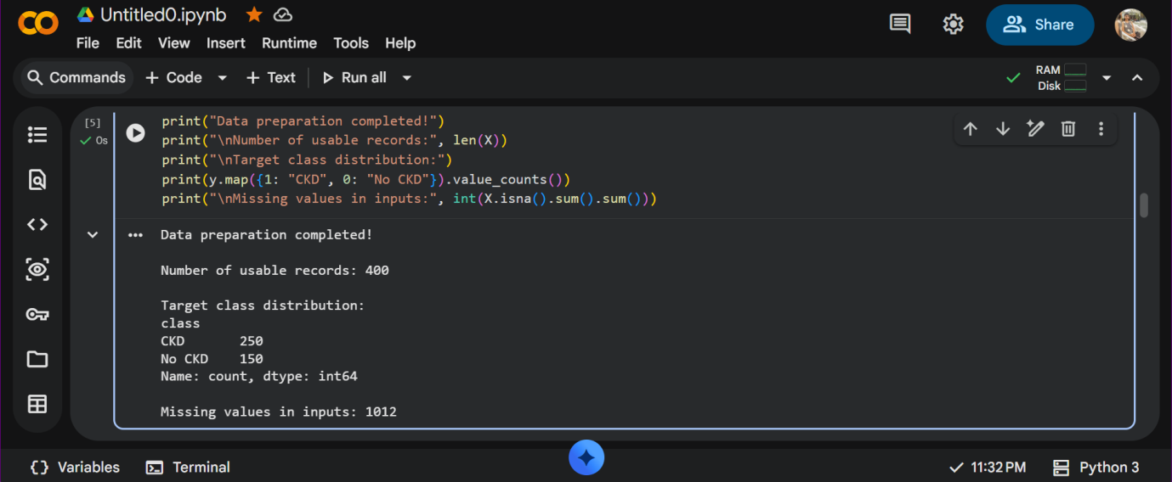

7.4 Model Evaluation

The trained model was evaluated on the testing dataset using accuracy, precision, recall, F1-score, and a confusion matrix.

The model achieved 100% accuracy on the selected test split of 80 records. This result reflects only this particular split and does not establish clinical reliability.
# Step 4: Encode data, train and evaluate the CKD model

from sklearn.preprocessing import LabelEncoder
from sklearn.impute import SimpleImputer
from sklearn.compose import ColumnTransformer
from sklearn.pipeline import Pipeline
from sklearn.preprocessing import OneHotEncoder
from sklearn.ensemble import RandomForestClassifier
from sklearn.model_selection import train_test_split
from sklearn.metrics import accuracy_score, classification_report, confusion_matrix

# Identify numeric and categorical columns
numeric_cols = X.select_dtypes(include=["number"]).columns.tolist()
categorical_cols = X.select_dtypes(exclude=["number"]).columns.tolist()

# Prepare preprocessing for both data types
preprocessor = ColumnTransformer(
transformers=[
("numeric", SimpleImputer(strategy="median"), numeric_cols),
("categorical", Pipeline([
("imputer", SimpleImputer(strategy="most_frequent")),
("encoder", OneHotEncoder(handle_unknown="ignore"))
]), categorical_cols)
]
)

# Split data into training and testing sets
X_train, X_test, y_train, y_test = train_test_split(
X, y, test_size=0.20, random_state=42, stratify=y
)

# Create the complete model pipeline
model = Pipeline([
("preprocessor", preprocessor),
("classifier", RandomForestClassifier(
n_estimators=200, random_state=42, class_weight="balanced"
))
])

# Train the model
model.fit(X_train, y_train)

# Evaluate on unseen test records
y_pred = model.predict(X_test)

print("Model training completed successfully!")
print("Training records:", len(X_train))
print("Testing records:", len(X_test))
print("Test accuracy:", round(accuracy_score(y_test, y_pred) * 100, 2), "%")
print("\nClassification Report:")
print(classification_report(
y_test, y_pred, labels=[0, 1],
target_names=["No CKD", "CKD"], zero_division=0
))
print("Confusion Matrix:")
print(confusion_matrix(y_test, y_pred, labels=[0, 1]))

Output: The evaluation metrics were generated to examine the model's classification performance.
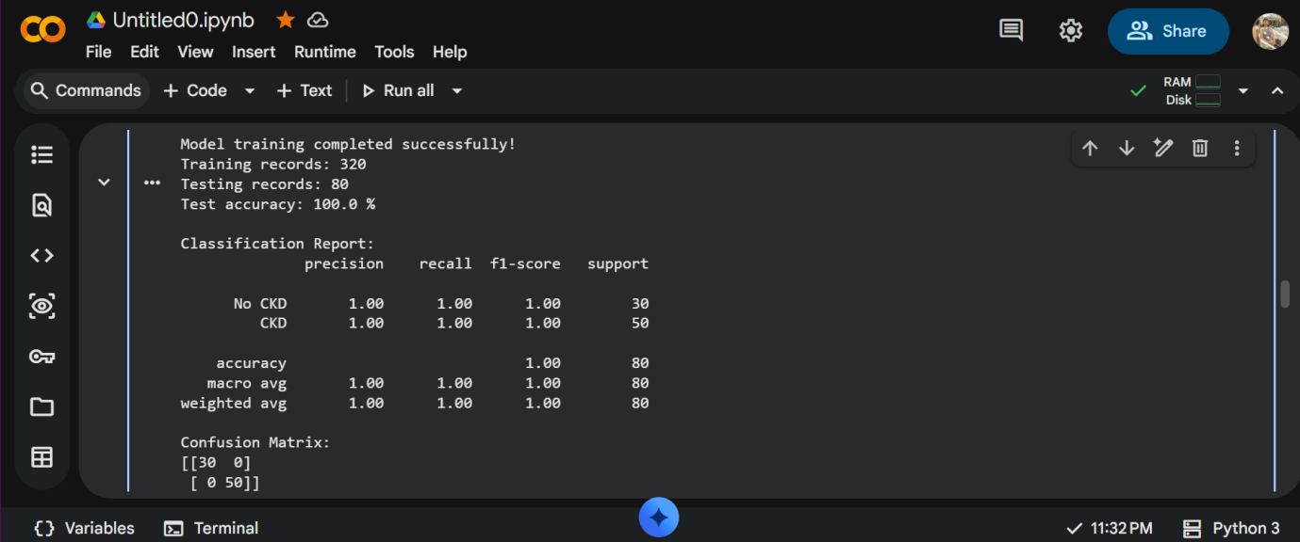

7.5 Sample Prediction

A sample patient record from the test dataset was passed to the trained model to demonstrate its prediction capability.

For the selected sample, the model predicted No Chronic Kidney Disease. The prediction and associated class probabilities were displayed in Google Colab.
# 5. Prediction / Inference

# Select one patient from the test dataset
sample_patient = X_test.iloc[[0]]

# Display the patient's input features
print("Sample Patient Details:")
display(sample_patient)

# Generate prediction
prediction = model.predict(sample_patient)[0]
probabilities = model.predict_proba(sample_patient)[0]

# Display prediction
print("\nPrediction Result:")
if prediction == 1:
print("Predicted Class: Chronic Kidney Disease (CKD)")
else:
print("Predicted Class: No Chronic Kidney Disease (No CKD)")

print("\nModel Probability Estimates:")
for label, probability in zip(
model.named_steps["classifier"].classes_,
probabilities
):
name = "CKD" if label == 1 else "No CKD"
print(f"{name}: {probability * 100:.2f}
print(
"\nActual Dataset Class:",
"CKD" if y_test.iloc[0] == 1 else "No CKD"
)

Output: The model generated a predicted class for the selected sample record.
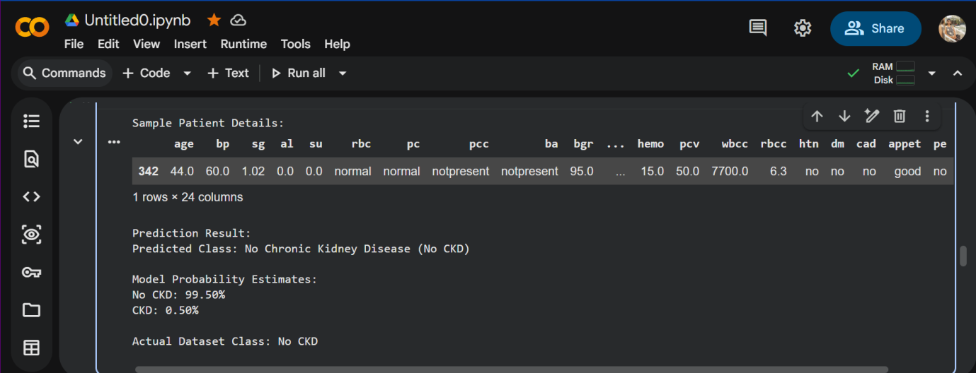

7.6 Confusion Matrix Visualization

A confusion matrix was generated to compare the actual classes with the predicted classes.

For the test split, all 80 records were classified correctly: 30 No CKD records and 50 CKD records. No misclassifications appeared in this particular test result.

The confusion matrix was saved as "ckd_confusion_matrix.png".
# 6. Visual Report: Confusion Matrix

import matplotlib.pyplot as plt
from sklearn.metrics import ConfusionMatrixDisplay

ConfusionMatrixDisplay.from_predictions(
y_test,
y_pred,
labels=[0, 1],
display_labels=["No CKD", "CKD"],
cmap="Blues",
values_format="d"
)

plt.title("CKD Prediction - Confusion Matrix")
plt.tight_layout()
plt.savefig("ckd_confusion_matrix.png", dpi=300, bbox_inches="tight")
plt.show()

print("Confusion matrix graph saved successfully!")

Output: A confusion matrix graph showing the classification results.
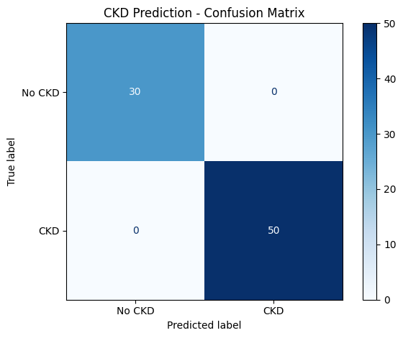

7.7 Feature Importance

The Random Forest model was used to calculate feature importance scores. These scores indicate the relative contribution of input features to the model's predictions.

A bar graph was generated to display the feature importance scores. The graph helps illustrate which processed features the model relied on most.

Feature importance does not prove that a feature causes kidney disease or is medically significant.

# 7. Feature Importance Analysis

feature_names = model.named_steps[
"preprocessor"
].get_feature_names_out()

importances = model.named_steps[
"classifier"
].feature_importances_

importance_df = pd.DataFrame({
"Feature": feature_names,
"Importance": importances
}).sort_values("Importance", ascending=False)

print("Top 10 important features:")
display(importance_df.head(10))

# Plot the top 10 features
top_features = importance_df.head(10).sort_values(
"Importance", ascending=True
)

plt.figure(figsize=(9, 6))
plt.barh(top_features["Feature"], top_features["Importance"])
plt.xlabel("Feature Importance")
plt.ylabel("Input Feature")
plt.title("Top 10 Features in CKD Prediction")
plt.tight_layout()
plt.savefig("ckd_feature_importance.png", dpi=300, bbox_inches="tight")
plt.show()

Output: The feature importance graph was saved as "ckd_feature_importance.png".
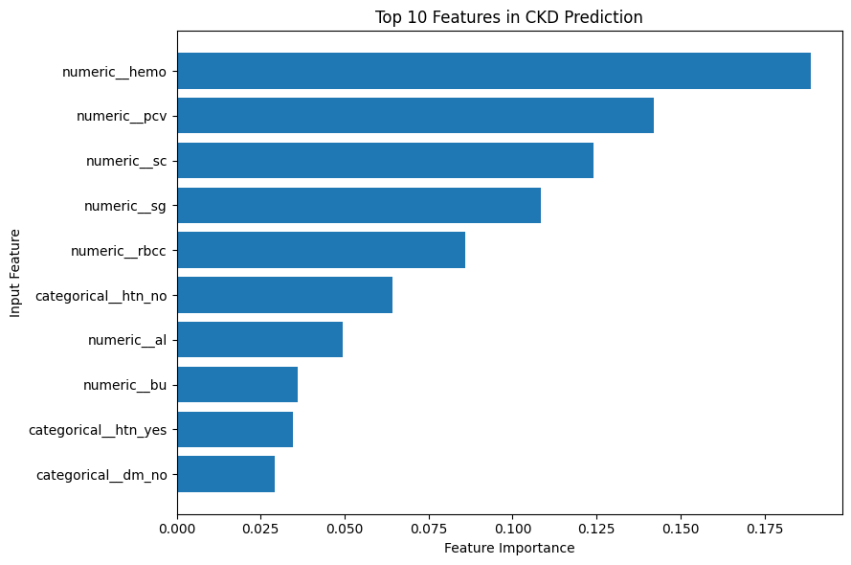

7.8 Saving the Trained Model

The trained preprocessing and classification pipeline was saved using the Joblib library.

The model was stored in the file "ckd_prediction_model.pkl". Saving the pipeline allows it to be loaded later for predictions without retraining, provided the compatible software environment and required input format are available.

The Google Colab notebook was also downloaded for future reference.
# Step 8: Save the trained CKD prediction model

import joblib

model_filename = "ckd_prediction_model.pkl"

joblib.dump(model, model_filename)

print("Model saved successfully!")
print("File name:", model_filename)

Output: The trained model file and notebook were saved successfully.

8. RESULTS AND DISCUSSION

8.1 Classifier Performance

The Chronic Kidney Disease Prediction system was trained using the Random Forest classification algorithm. The dataset was divided into 80% training data and 20% testing data.

The model achieved 100% accuracy on the selected test dataset of 80 records. In the confusion matrix, 30 records belonging to the No CKD class and 50 records belonging to the CKD class were correctly classified.

These results show that the model performed well on this particular test split. However, further testing is required to determine how well it performs on new and unseen data.

8.2 Sample Prediction

After training, the model was tested using a sample record from the test dataset. The model predicted the class as No Chronic Kidney Disease for the selected sample.

This demonstrates that the trained model can accept patient-related input features and generate a prediction based on patterns learned from the dataset.

8.3 Feature Importance

The feature importance graph was generated to identify which input features contributed most to the Random Forest model's predictions.

Feature importance helps in understanding the model and identifying potentially influential variables. However, it does not prove that a feature causes Chronic Kidney Disease.

Insert the downloaded feature importance graph here.

8.4 Limitations

The project has the following limitations:

1. The dataset contains a limited number of records.
2. Some dataset values were missing and required preprocessing.
3. The reported accuracy is based on a single train-test split.
4. The model requires additional validation using other datasets.
5. The prediction is for educational purposes and must not be used as a substitute for medical diagnosis.

9. CONCLUSION

The project, Chronic Kidney Disease Prediction Using Machine Learning, demonstrates how machine learning can be used to classify patient data into CKD and No CKD categories.

The UCI Chronic Kidney Disease dataset was used to train and test a Random Forest classifier. Missing values were handled using imputation techniques, and categorical features were converted into numerical form using one-hot encoding.

The model achieved 100% accuracy on the selected test split. A confusion matrix and feature importance graph were also generated to understand the model's performance.

This project helped demonstrate the basic stages of a machine learning workflow, including data collection, preprocessing, model training, evaluation, prediction, and saving the trained model. Further validation is necessary before considering its use in real-world healthcare.

10. FUTURE SCOPE

The project can be improved in the following ways:

1. Larger Dataset: Use more patient records to improve the evaluation of the model.
2. Model Comparison: Compare Random Forest with algorithms such as Logistic Regression, Decision Tree, and Support Vector Machine.
3. Cross-Validation: Use cross-validation to obtain a more reliable estimate of model performance.
4. User Interface: Develop a simple web application where users can enter input values and view predictions.
5. Model Improvement: Perform feature selection and hyperparameter tuning to evaluate possible improvements.
6. Real-World Validation: Test the model on independent, appropriately validated clinical data before any medical application.

11. REFERENCES

1. UCI Machine Learning Repository, “Chronic Kidney Disease Dataset.” Available at: https://archive.ics.uci.edu/dataset/336/chronic+kidney+disease

2. L. Breiman, “Random Forests,” Machine Learning, vol. 45, pp. 5–32, 2001.

3. F. Pedregosa et al., “Scikit-learn: Machine Learning in Python,” Journal of Machine Learning Research, vol. 12, pp. 2825–2830, 2011.

4. Scikit-learn Documentation. Available at: https://scikit-learn.org/stable/

5. Pandas Documentation. Available at: https://pandas.pydata.org/docs/

6. Joblib Documentation. Available at: https://joblib.readthedocs.io/

